**Plant Growth Experiment**

|  |  |  |  |  |
| --- | --- | --- | --- | --- |
|  | **ITEM** | **IMAGE** | **SPECIFICATION** | **DESCRIPTION** |
|  | Habitat chamber |  | Overall an Aluminum cube shape of 10 cm side length. | Cubical shape with a centered cylindrical space of 98 mm in diameter. |
| 1 | Lids |  | Aluminum material of 10cm width x 10cm length x 2cm depth. | (2) Bead Blast Finish.    (2) **Anodized** Finish  (dark bronze) |
| 2 | Bottoms |  | Aluminum material of 10cm width x 10cm length x 9cm depth. | (2) Bead Blast Finish.    (2) **Anodized** Finish  (dark bronze) |
| 3 | Free Plates |  | Aluminum material | (4) Bead Blast Finish. |
| 4 | Support Plates |  | Aluminum material |  |
| 5 | Seeds cassette |  | Material: Aluminum vs. Delrin | Seeds are sterilized and loaded into the dry Whatman filter paper and mounted in the seeds cassette. |
| 6 | Water Bag |  | 50 mL reservoir medication cassette  latex-free | Bag is used for water delivery system. |
| 7 | Water  Delivery Tube |  | Supplied with the water bag | Connected to the solenoid valve outlet on one end and the seeds cassette on the other end (secured on the bottom of the cassette) |
| 8 | Solenoid Lee Valve |  | **2-port, plug-in, 12**  **V valve Non-Latching**  LHDA1260245D B  **Manifold**  LFMX0524000A | Solenoid valve is activated once to release the water bag content entirely to the plant cassette. |
| 9 | Wave Spring |  | Part number  CM60-L3-S17 | Part Number CM30-L7-S17  Material Stainless Steel  Spring Type  Crest-to-Crest  Operates in Bore 60mm  Clears Shaft Diameter  50mm  Load 135.00N  Work Height 9.32mm  Free Height 19.05mm |
| 10 | Camera |  | ELP 2MP Fisheye camera | Collecting time-lapse images of 2-megapixel image quality. |
| 11 | LED PCB |  | * Horseshoe shape design to clear the passthrough inside the chamber. | Custom-made LED PCB |
| 12 | Passthrough/  Female  Connector |  | CONNECTOR, SUB-C,  HI-VAC PLUG  **(Only 9-PINS)** | (6) female connectors with pre-connected 20 cm wire length |
| 13 | Passthrough/  Male  Connector |  | Part Number:  SRISC501-1    CONNECTOR, SUB-C,  PLUG/PLUG, SC LBW | (3) male connectors |
| 14 | Passthrough/  Male  Connectors  **Welding** |  | WELDING QTY 3 CUST  SUPP FLANGE  WITH QTY 1  SRISC501 - LOT  CHARGE | (3) male connectors to be welded |
| 15 | M3 Screws and Washers |  | **8 M3x8** socket head cap screws plus, 8 M3 flat and lock  washers | Securing the chamber to the bus with 8 screws. |
| 16 | M4 Screws and Washers |  | **4 M4x20** socket head cap screws plus,  4 M4 washers | Securing the chamber’s bottom to the lid with 4 screws. |
| 17 | M2 Screws |  | **4 M2x4** socket head cap screws | Securing the camera to the support plate |
| 18 | O-rings |  | Oil-Resistant Buna-N  O-Ring  3.5 mm Wide 86 mm ID | Provides the chamber with air-tight seal |
| 19 | O-ring  Lubricant |  | Dow Corning Vacuum  Lubricant 5.3oz Tube | Lubricant for O ring providing airtight seal. |
| 20 | Aluminum mesh |  | Aluminum Woven  Mesh Sheet,  Unpolished (Mill)  Finish, ASTM E2016-  06, 12" Width, 12"  Length, 0.02" Wire  Diameter, 51% Open  Area | Aluminum mesh  (replacing plastic canvas for seeds  support) |

**Vendors’ List**

**Water Bag/Water Delivery Tube:**

Smiths Medical Part #21-7301-24 - RESERVOIR MEDICATION CASSETTE 50ML FEMALE LUER

LATEX-FREE (12/BX)

SALES & SUPPORT: Call 312-321-8914

C.I.A. Medical

312-275-5850 x225

[www.ciamedical.com](http://www.ciamedical.com/)

HR Medical, Inc.

1768 W. Sam Houston Pkwy

Houston, Texas 77043-2723 USA

info@hrmedical.com 800-588-5603

[www.hrmedical.com](http://www.hrmedical.com/)

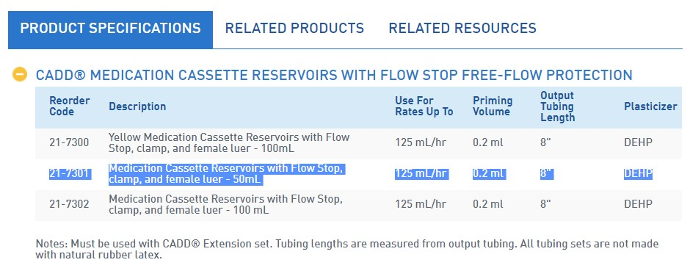

**Lee Solenoid Valves:**

THE LEE COMPANY

1250 Bayhill Drive, #113

San Bruno, CA 94066 M: (415) 653-9022 https://www.theleeco.com

**NOTES:**

* 1. TYPE: 2 WAY, NORMALLY CLOSED, 2 POSITION, SOLENOID VALVE.
  2. WETTED MATERIALS: PBT (HOUSING & COVER), 316 SS (SPRING), FeCr ALLOY (PLUNGER STOP & ARMATURE), FKM (O-RINGS), EPOXY. SEE TABLE FOR PLUNGER HEAD AND SEAL MATERIAL.
  3. ELECTRICAL SPECIFICATIONS: 3.1 OPERATING VOLTAGE: (SEE TABLE). 3.1.1 SPIKE AND HOLD DRIVER REQUIRED: SPIKE AT ACTUATION VOLTAGE (SEE TABLE) FOR 10 ms THEN REDUCE TO HOLD VOLTAGE (SEE TABLE).
  4. OPERATING PRESSURE: 4.1 SYSTEM: VAC TO 50 PSIG [VAC TO 345 kPag] COMMON PORT INLET. 4.2 MAXIMUM DIFFERENTIAL: 50 PSID [345 kPad].
  5. FLOW CAPACITY: 450 LOHMS MAXIMUM (AIR).
  6. OPERATING TEMPERATURE: 40°F TO 120°F [4°C TO 49°C].
  7. STORAGE TEMPERATURE: -40°F TO 175°F [-40°C TO 80°C].
  8. OPERATING FLUID: COMPATIBLE GASES AND LIQUIDS.
  9. INSTALLATION INFORMATION: 9.1 INSTALLATION HOLE: SEE LEE CO DRAWING LCFX0300100B.

**Wave Spring:**

[www.smalley.com](http://www.smalley.com/)

**Passthrough:**

SRI Hermetics [www.srihermetics.com/](http://www.srihermetics.com/)

**O-ring grease:**

**Dow Corning Vacuum Lubricant 5.3oz Tube**

Designed for sealing and lubricating vacuum and pressure systems.Low vapor pressure, stiff, nonmelting silicone lubricant maintains its consistency from -40° to +204°C (-40° to +400°F).Resists oxidation and chemicals; noncarbonaceous

[https://www.amazon.com/Dow-Corning-Vacuum-Lubricant-5-](https://www.amazon.com/Dow-Corning-Vacuum-Lubricant-5-3oz/dp/B001UHMNW0/ref=sr_1_1?s=industrial&ie=UTF8&qid=1513650017&sr=1-1&keywords=Stopcock+grease)

[3oz/dp/B001UHMNW0/ref=sr_1_1?s=industrial&ie=UTF8&qid=1513650017&sr=11&keywords=Stopcock+grease](https://www.amazon.com/Dow-Corning-Vacuum-Lubricant-5-3oz/dp/B001UHMNW0/ref=sr_1_1?s=industrial&ie=UTF8&qid=1513650017&sr=1-1&keywords=Stopcock+grease)

**Aluminum mesh:**

Aluminum Woven Mesh Sheet, Unpolished (Mill) Finish, ASTM E2016-06

Amazon.com [https://www.amazon.com/Aluminum-Unpolished-Finish-E2016-06Diameter/dp/B005H2SFJE/ref=sr_1_1?ie=UTF8&qid=1513647913&sr=81&keywords=Aluminum+Woven+Mesh+Sheet%2C+Unpolished](https://www.amazon.com/Aluminum-Unpolished-Finish-E2016-06-Diameter/dp/B005H2SFJE/ref=sr_1_1?ie=UTF8&qid=1513647913&sr=8-1&keywords=Aluminum+Woven+Mesh+Sheet%2C+Unpolished)

**O-ring, screws and washers:**

Oil-Resistant Buna-N O-Ring 3.5 mm Wide, 86 mm ID mcmaster.com